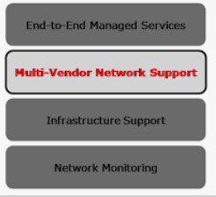

End-to-End Managed Service

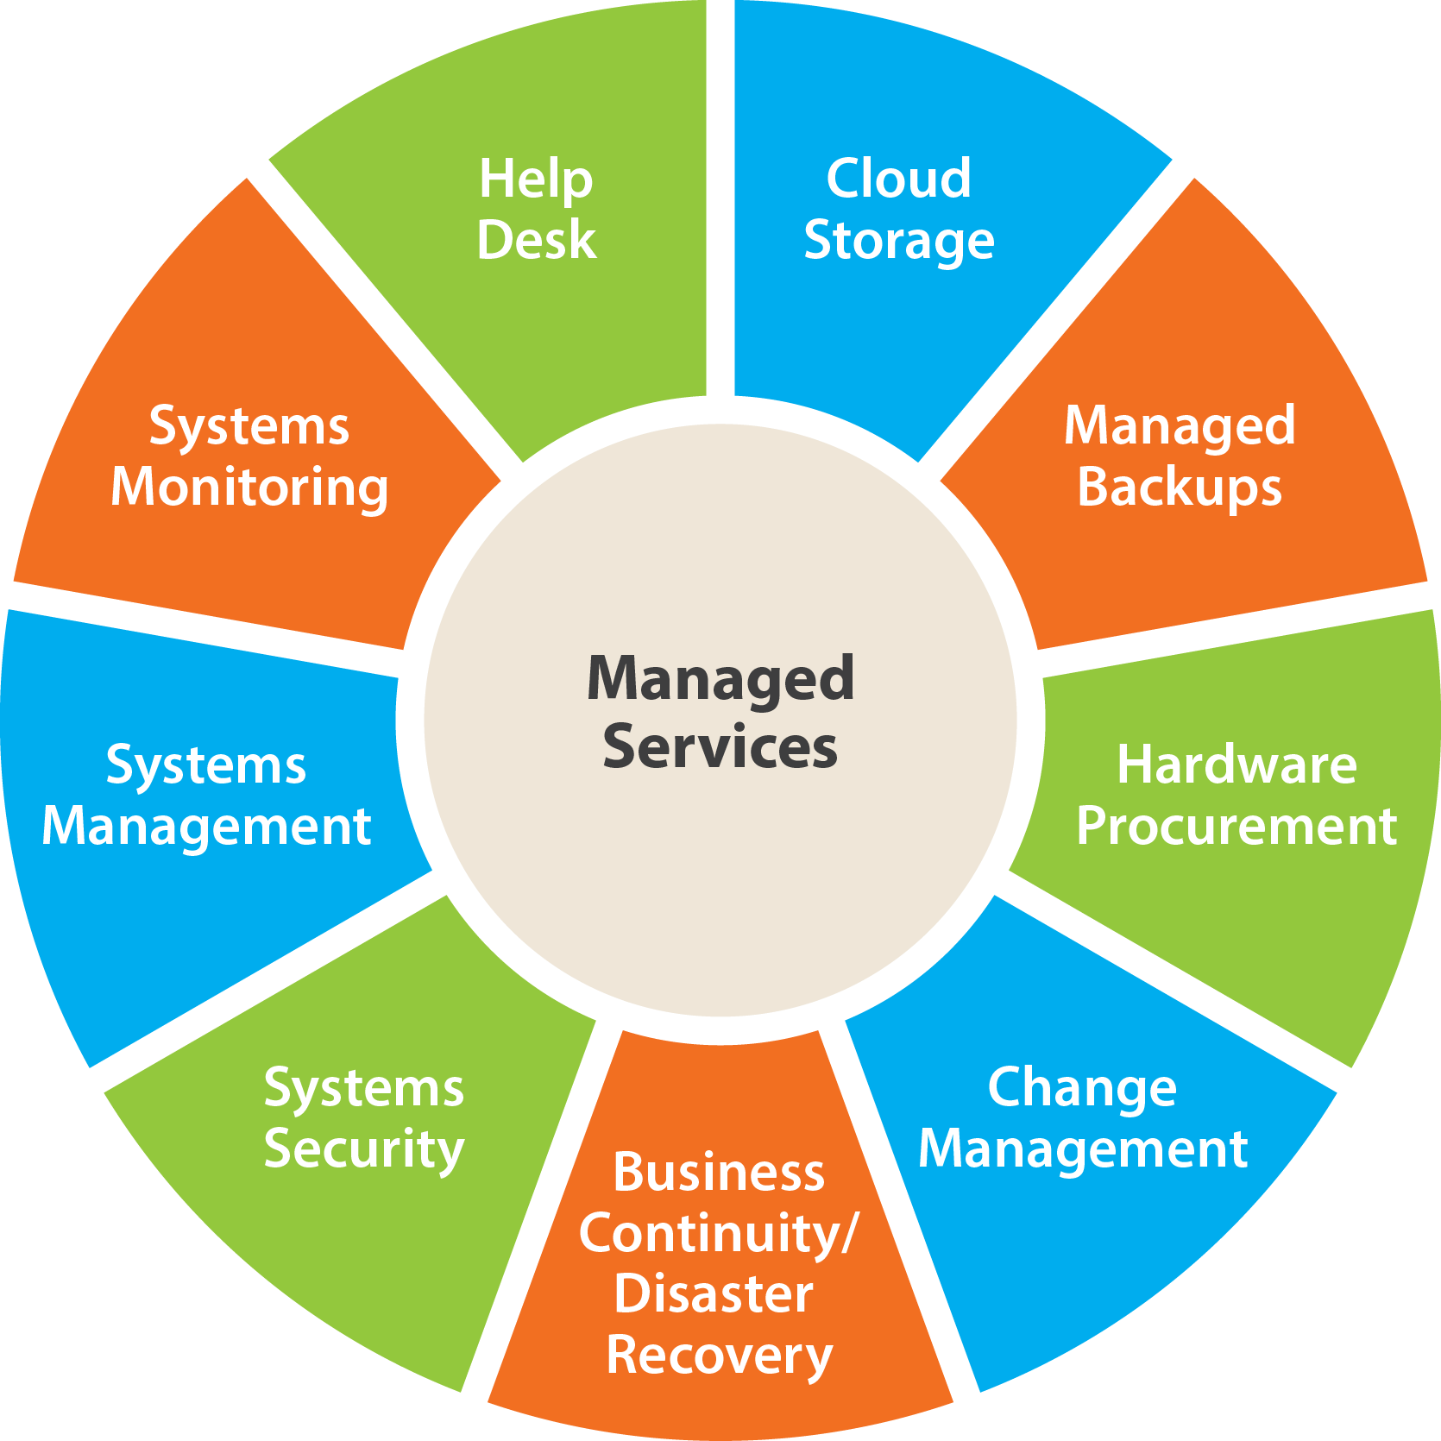

**B&S ICT SERVICES LTD** Managed Services are the practice of outsourcing customers IT management responsibilities and functions as a strategic method by defining SLA’s, with better manageability and enriching user experience. This includes various support and lifecycle build/maintenance activities. Our Managed Services has brought flexibility, cost-savings, and efficiency throughout our customer base.

Managing Infrastructure, Resources & Assets, Analysing Crucial Pieces of Data, Assessing, Monitoring and Observing Networks & Systems providing Continuous Support to ensure smooth functioning of business operations so that you could go ahead with all your important business decisions. You need Managed Services that transforms your network operations enabling higher levels of performance.

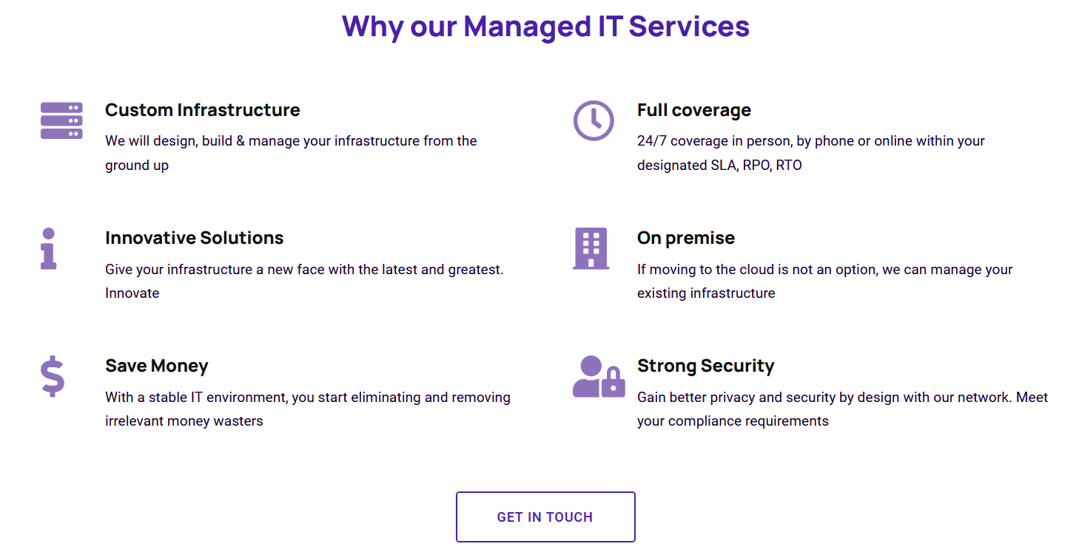

**Multi-vendor support services**



Comprehensive and collaborative multi-vendor support to help you simplify the management of your heterogeneous digital infrastructure.

## Introduction: Simplified Support: Features and Benefits: Our Experts

The fast-paced and ever-changing challenges of supporting multi-vendor networks and environments get exponentially more difficult as an organization adds new technology to their IT infrastructure, new support agreements, updates levels of service, or updates warranties – with each vendor.

Our multi-vendor support services can help you not only cut costs and increase productivity across your IT organisation, but also lessen the burden on resources already managing too many day-to-day administrative tasks.

Multi-Vendor Support Service (MVS) provides a single point of contact for Customers’ hardware and software maintenance support, delivered direct or via 3rd party service providers which have been pre-determined and authorised by Softcat.  
MVS Service offers all-in-one tech support through full consolidation and management of Customers’ various support contracts.(eg.Cisco,Oracle,Checkpoint,Meraki,F5,HPE)

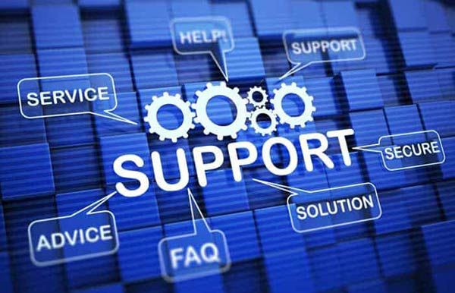

**Simplified Support To Save You Money, Effort, and Time**

The idea of simplified network support doesn’t stop at the appliances or even services. As an IT manager, you also want that ease of management when it comes to your maintenance. With our multi-vendor support we can consolidate your support services contracts, simplifying support for your mixed environment, ultimately saving you money, effort, and time.

* **Improve services**. You can take advantage of the award-winning support level of service on all assets in your multivendor environment, including Juniper Networks, F5 Networks, Palo Alto Networks, Cisco, Fortinet and many more.
* **Simplify IT**. Consolidate your hardware support under one service contract, knowing who to reach out to every time - one less thing to worry about.
* **Improve efficiency**. Streamline processes for managing warranty renewals across multiple hardware vendors.
* **Cost savings**. Avoid unnecessary operating costs by efficiently managing expiring warranties and supporting hardware beyond three years.
* Features and benefits

**Optimize IT Maintenance And Support For Your Hybrid Environment**

**Features**

Direct Vendor support where necessary

24x7x365 technical support

4-hour, next business day, or other SLAs for both parts and labor

Collaborative hardware and software support

Case and escalation management

Hardware break/fix

Vendors to include but not limited to IBM, Lenovo, Dell/EMC, NetApp,

Software: VMware, Microsoft, RedHat, SuSe, Aix, etc

Networks- Cisco, Fortinet, Broadcom, Brocade, Huawei, Point, Juniper, Extreme Networks.

**Benefits**

* One point of contact for all your services
* Alignment of existing contract terms with Vendors



**Support services**

**Get Better Support For Your Business Today**

Extend your IT team with our support services, enabling you to address issues before they impact your business.

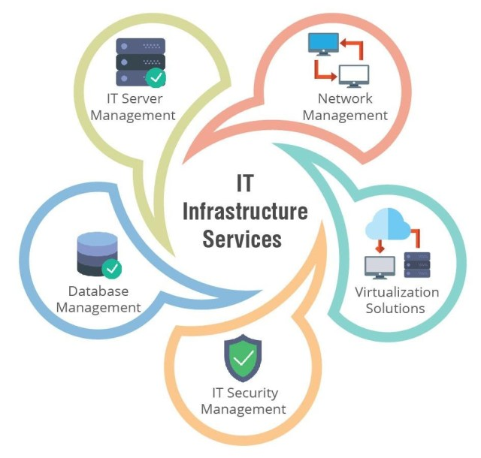

#### IT Infra means care of serious policy, process and data for overall success. Finally using our IT Infra Services clients have normal earned cost cut, control order and improve customer service etc. Overall IT Infra is close line up with reach steps and goals. IT Infra also include  all parts that help the firm  value of data and details.

#### IT Services Offered:

* Firewall Solution – [Fortigate](https://qsmart.qa/services/fortinet-firewall-in-doha-qatar/), [SonicWall](https://www.sonicwall.com/), [Cisco](https://www.cisco.com/c/en/us/products/security/asa-firepower-services/index.html), [Sophos](https://www.sophos.com/en-us/products/next-gen-firewall.aspx)
* Server Solution – Dell, HP, Lenovo, IBM, CISCO,
* Storage Solution – Western Digital, Synology, QNAP, Dell, Lenovo, IBM, Hitachi, Huawei
* Antivirus Solution – Symantec, Kaspersky, Avast, McAfee
* WiFi Solution – [Aruba](https://www.arubanetworks.com/products/networking/access-points/), [Fortinet](https://qsmart.qa/services/fortinet-firewall-in-doha-qatar/), [Cisco](https://www.cisco.com/c/en/us/products/wireless/access-points/index.html)
* Data Center Solution- Security, Access control, Automatic fire detection and Extinguishing Systems, Networking, Electrical wiring, Raised floors, Containerised Datacentres e.t.c

#### We can Assist our clients with:

* Support for devices, servers, firewalls, pc and backup devices etc.
* Monitor and maintain of your system infrastructure.
* Onsite and remote support includes a service desk.

As a premier IT Service provider company, we service customers in the whole of East Africa region and helps to less downtime and offer quality services on correct time with expert control.



The above links will direct to [info@bands-ict.co.ke](mailto:info@bands-ict.co.ke) for **Request a quote** and telephone numbers for **Talk to an expert**

Contacts:

**General Line:** +254 20 5227570

**Sales:** +254 788 175 734 / +254 757564696

**Technical:** +254 770 629 086

Email: ifo@bands-ict.co.ke

#2254D7